1. Create a new react application using *create-react-app* tool with the name as “blogapp”
2. Open the application using VS Code
3. Create a new file named as **Post.js** in **src folder** with following properties

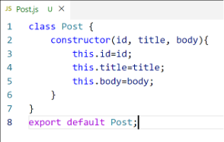

*Figure 2: Post class*

1. Create a new class based component named as **Posts** inside **Posts.js** file

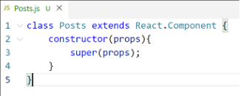

*Figure 3: Posts Component*

1. Initialize the component with a list of Post in state of the component using the constructor
2. Create a new method in component with the name as **loadPosts()** which will be responsible for using Fetch API and assign it to the component state created earlier. To get the posts use the url (<https://jsonplaceholder.typicode.com/posts>)

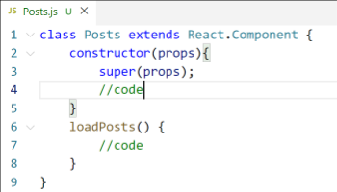

*Figure 4: loadPosts() method*

1. Implement the **componentDidMount()** hook to make calls to **loadPosts()** which will fetch the posts

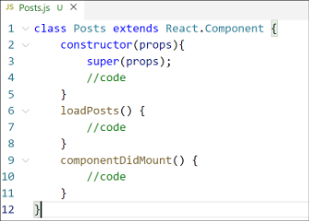

*Figure 5: componentDidMount() hook*

1. Implement the **render()** which will display the title and post of posts in html page using heading and paragraphs respectively.

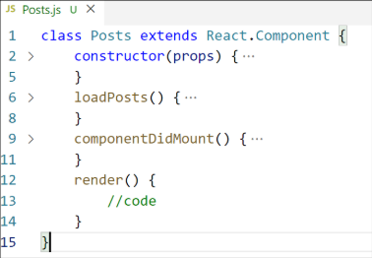

*Figure 6: render() method*

1. Define a **componentDidCatch()** method which will be responsible for displaying any error happing in the component as alert messages.

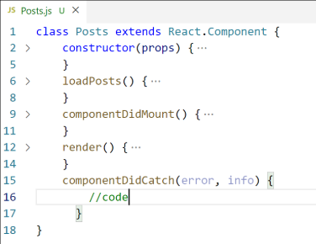

*Figure 7: componentDidCatch() hook*

1. Add the Posts component to App component.
2. Build and Run the application using *npm start* command.

**CODE:**

**File: Post.js**

class Post {

constructor(id, title, body) {

this.id = id;

this.title = title;

this.body = body;

}

}

export default Post;

**File: Posts.js**

// Posts.js

import React, { Component } from 'react';

import Post from './Post';

class Posts extends Component {

constructor(props) {

super(props);

this.state = {

posts: [],

hasError: false

};

}

// Load posts using fetch

loadPosts() {

fetch("https://jsonplaceholder.typicode.com/posts")

.then((response) => response.json())

.then((data) => {

const postObjects = data.map(

(item) => new Post(item.userId, item.id, item.title, item.body)

);

this.setState({ posts: postObjects });

})

.catch((error) => {

console.error("Error fetching posts:", error);

this.setState({ hasError: true });

});

}

// Lifecycle method

componentDidMount() {

this.loadPosts();

}

// Error boundary

componentDidCatch(error, info) {

alert("Something went wrong: " + error);

}

render() {

return (

<div>

<h1>Blog Posts</h1>

{this.state.posts.map((post) => (

<div key={post.id} style={{ marginBottom: "20px" }}>

<h2>{post.title}</h2>

<p>{post.body}</p>

</div>

))}

</div>

);

}

}

export default Posts;

**File: App.js**

import React from 'react';

import Posts from './Posts';

function App() {

return (

<div className="App">

<Posts />

</div>

);

}

export default App;

**OUTPUT:**

We